**Java Collections**

**What are Java collections?** They are, as the name implies, a collection of things, it can be a collection of arrays. Similar to arrays, they hold objects in a list that can be sorted, unsorted, in order or out of order. Quote from website Oracle “*A collection — sometimes called a container — is simply an object that groups multiple elements into a single unit. Collections are used to store, retrieve, manipulate, and communicate aggregate data. Typically, they represent data items that form a natural group, such as a poker hand (a collection of cards), a mail folder (a collection of letters), or a telephone directory (a mapping of names to phone numbers). If you have used the Java programming language — or just about any other programming language — you are already familiar with collections.”*

[*http://docs.oracle.com/javase/tutorial/collections/intro/index.html*](http://docs.oracle.com/javase/tutorial/collections/intro/index.html)

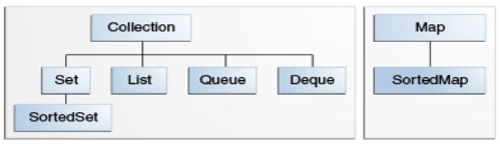

All these can be arrays, and they are part of the collection

and they’re called INTERFACES

How do they look like?

How are they used?

What are things to look for when using Java collections?